CHAPTER 9: Sedimentary, igneous and metamorphic rocks
Worksheet 9.3

Sedimentary rocks
Student: Class:

Rock face
1. Photograph A shows a rock face in a road cutting. Photographs B, C and D show three rocks.
A | 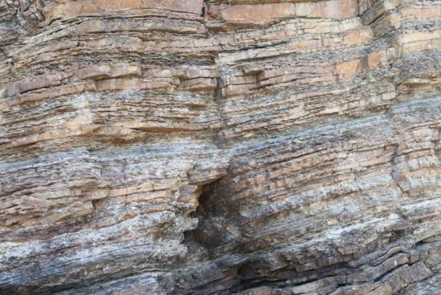 | B | 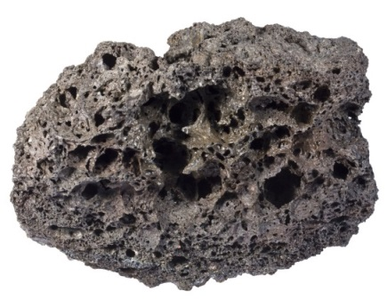
C | 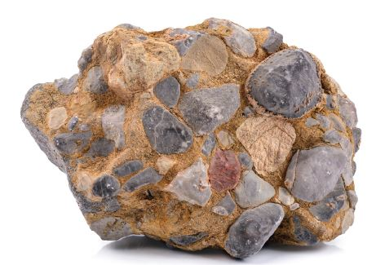 | D | 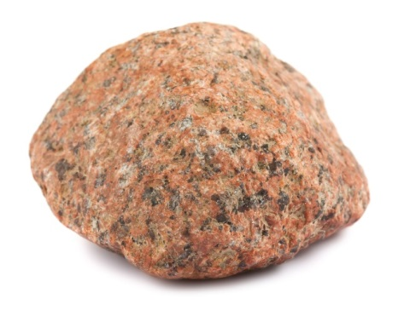
(a) Explain how a student studying photograph A would decide that the rocks shown were probably sedimentary. They are bedding in layers
(b) Closer examination of the rocks in the road cutting confirmed they were sedimentary. Identify which rock sample (B, C or D) would most likely be found in this road cutting. Explain your answer.
C This rock is conglomerate, whereas the other rocks are igneous.
Photo A: Sujin Jetkasettakorn / 123RF.com
Photo B: Siim Sepp / 123RF.com
Photo C: sonsam / Shutterstock.com
Photo D: Andrey Eremin / 123RF.com

Types of sedimentary rocks
2. (a) The following table provides  information on the types of sedimentary  rocks. Complete the table by naming  the sediments that form each rock. |  |  |  |  | (b) Construct a pie chart of the types of sedimentary rocks in the space below.  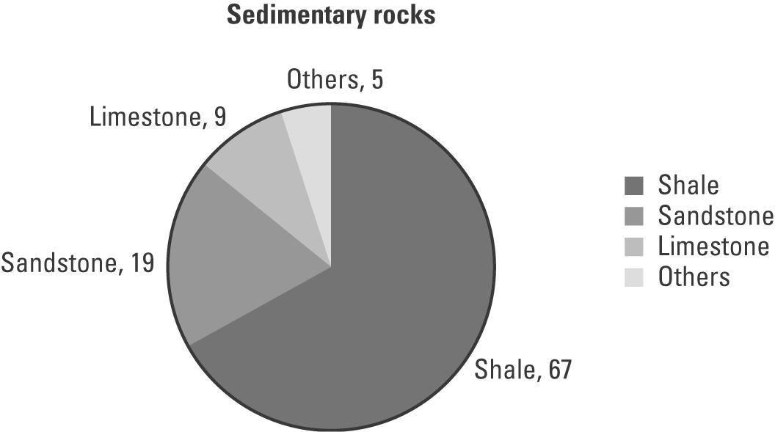
 | Sediment | Rock type | %
 | Clay | Shale | 67
 | Sand | Sandstone | 19
 | Calcite | Limestone | 9
 |  | Other sedimentary rocks | 5

